

**Excel Assignment - 6**

1. What are the various elements of the Excel interface? Describe how they're used.

Answer:

1. Quick Access Toolbar

This toolbar is located in the upper left corner of the screen. Its objective is to show the most frequently used Excel commands. We can customize this toolbar based on our preferred commands.

### File Tab

Excel 2007's Office button has been replaced by the File tab. We can click it to **check the Backstage view**, where we can **open** or **save files, create new sheets, print sheets**, and perform other **file-related operations**.

### 3. Title Bar

The title bar of the spreadsheet is at the top of the window. It displays the **active document's name.**

### 4. Control Buttons

Control buttons are the symbols that are present in the **upper-right side** of the window, enabling us to change the **labels, minimize, maximize, share,** and **close the sheet.**

### 5. Menu Bar

Under the **diskette** or **save icon** or the **excel icon** (this will depend on the version of the program**), labels** or **bars** which enable changing the sheet which is shown. These are the menu bar and contain a **File, Insert, Page Layout, Formulas,** **Data, Review, View, Help,** and a **Search Bar** with a **light bulb** icon. These menus are divided into subcategories which simplify the distribution of information and analysis of calculations.

### 6. Ribbon/Toolbar

Each menu bar contains several different elements. On the selection of the menu, a sequence of command **options/icons** will show on a ribbon. For example, if we select the **"Home"** tab, we will see **cut, copy, paste, bold, italic, underline**, and **more** commands. In the same way; we can click on the **"Insert"** tab, we will see **tables, illustrations, additional, recommended graphics, graphics maps,** among others. On the other hand, if we select the **"Formulas"** option. **Insert functions, auto sum recently used, finances, logic, text, time, date,** etc.

* **Tabs**They are the Ribbon's top part, and they include groups of related commands. Ribbon tabs include **Home, Insert, Page Layout, Formula, Data.**
* **Groups**They organize related commands; the name of each group is displayed below the Ribbon. For example, a set of commands related to fonts or a group of commands related to alignment, etc.
* **Commands**They appear within each group, as previously stated.

### 7. Dialog Box Launcher

Dialog box launcher is a very little down arrow that is present in the **lower-right** corner of a command group on the Ribbon. By clicking on this arrow, we can explore more options related to the concerned group.

### 8. Name box

Show the location of the active cell, row, or column. We have the option of selecting multiple options.

### 9. Formula Bar

Formula bar permits us to observe, insert or edit the information/formula entered in the active cell.

### 10. Scrollbars

Scrollbars are the tools that enable us to **move the document's vertical** and **horizontal** views. We can activate this by clicking on the platform's internal bar or the arrows we have on the sides. Additionally, we can use the **mouse wheel** in order to automatically scroll up or down: or use the directional keys.

### 11. Spreadsheet Area

It is the place where we enter our data. It includes all the **rows, cells, columns**, and **built-in data** in the spreadsheet. We can use shortcuts to perform toolbar activities or formulas of **arithmetic operations (add, subtract, multiply, etc.)**. The insertion point is the blinking vertical bar known as the **"cursor."** It specifies the insertion location of the typing.

### 12. Leaf Bar

Leaf bar is present at the bottom of the spreadsheet, which says **sheet1** is shown. This sheet bar describes the spreadsheet which is currently being worked on. Using this, we can alternate a number of sheets or add a new one as per our convenience.

### 13. Columns Bar

Columns are a vertically ordered series of boxes across the full sheet. This column bar is located below the formula bar. The letters of the alphabet are used to label the columns. Begin with the letter **A** to **Z,** and then after **Z**, it will continue as **AA, AB,** and so on. The number of columns that can be used is limited to **16,384.**

### 14. Rows Bar

The row bar is the left part of the sheet where a sequence of numbers is expressed. Begin with number one (1), and further rows will be added as we move the pointer down. There are a total of **1,048,576** rows available.

### 15. Cells

Cells are those parallelepipeds that divide the spreadsheet into many pieces, separating rows and columns. A spreadsheet's first cell is represented by the first letter of the alphabet and the number one **(A1).**

### 16. Status Bar

The status bar is present at the bottom of the window that displays critical information. It also indicates whether something is incorrect or whether the document is ready to be printed or delivered.

This shows the result of the selected digits such as **sum, average, count, maximum, minimum,** etc.

By **right-clicking** on the **status bar**, we can configure the **status bar**. Any command from the specified list can be added or removed.

### 17. View Buttons

View buttons are a set of three buttons arranged at the left of the Zoom control, close the screen's right-bottom corner. We can see three different kinds of sheet views in Excel using this method.

* **Normal View:** - Normal view displays the Excel page in normal view.
* **Page Layout View:** - The Page Layout view shows the precise layout of an Excel page it will be printed.
* **Page Break View:** - This displays page break preview before printing.

### 18. Zoom Control

The zoom control is present at the **lower-right** side of the window. It enables us to **ZOOM-IN** or **ZOOM-OUT** a specific area of the spreadsheet. It is represented by magnifying icons with the symbols of **maximizing (+)** or **minimizing (-).**

2. Write down the various applications of Excel in the industry.

Answer:

* Data Entry and Storage

### Performing Calculations

### Data Analysis and Interpretation

### Reporting and Visualizations

* Data organization: Excel allows users to organize and store large amounts of data in a structured and efficient manner.
* Data analysis: Excel provides a wide range of tools and functions that can be used to analyze and make sense of numerical data.
* Visualization: Excel enables users to create charts, graphs, and pivot tables to visualize data and gain insights into trends and patterns.
* Forecasting: Excel's forecasting features allow users to predict future trends based on historical data.

3. On the ribbon, make a new tab. Add some different groups, insert commands in the groups and name them according to their commands added. Copy and paste the screenshot of the steps you followed.

Answer: 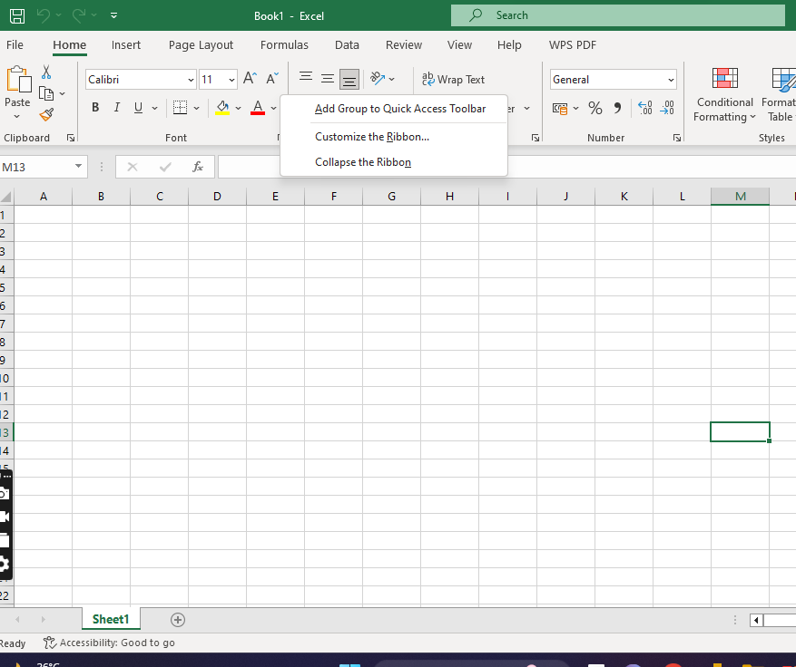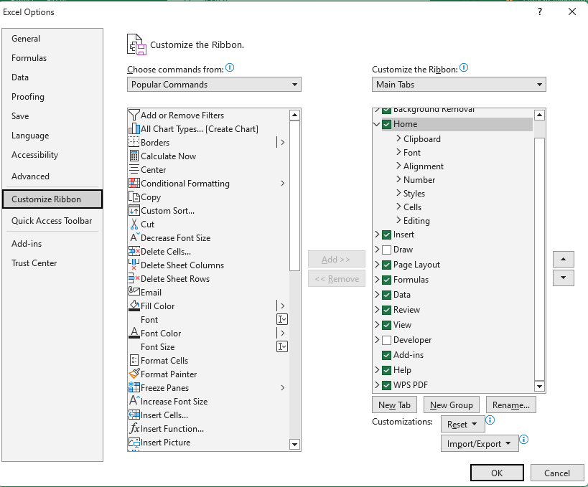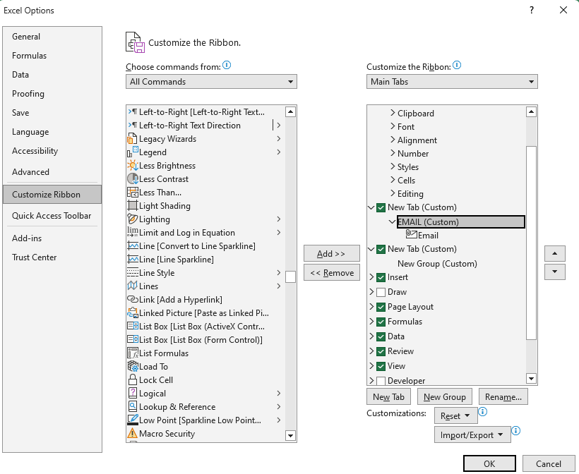

4. Make a list of different shortcut keys that are only connected to formatting with their functions.

Answer:

| Open the **Format Cells** dialog box. | Ctrl+1 |
| --- | --- |
| Format fonts in the **Format Cells** dialog box. | Ctrl+Shift+F or Ctrl+Shift+P |
| Edit the active cell and put the insertion point at the end of its contents. Or, if editing is turned off for the cell, move the insertion point into the formula bar. If editing a formula, toggle Point mode off or on so you can use the arrow keys to create a reference. | F2 |
| Insert a note.  Open and edit a cell note. | Shift+F2  Shift+F2 |
| Insert a threaded comment.  Open and reply to a threaded comment. | Ctrl+Shift+F2  Ctrl+Shift+F2 |
| Open the **Insert** dialog box to insert blank cells. | Ctrl+Shift+Plus sign (+) |
| Open the **Delete** dialog box to delete selected cells. | Ctrl+Minus sign (-) |
| Enter the current time. | Ctrl+Shift+Colon (:) |
| Enter the current date. | Ctrl+Semicolon (;) |
| Switch between displaying cell values or formulas in the worksheet. | Ctrl+Grave accent (`) |
| Copy a formula from the cell above the active cell into the cell or the formula bar. | Ctrl+Apostrophe (') |
| Move the selected cells. | Ctrl+X |
| Copy the selected cells. | Ctrl+C |
| Paste content at the insertion point, replacing any selection. | Ctrl+V |
| Open the **Paste Special** dialog box. | Ctrl+Alt+V |
| Italicize text or remove italic formatting. | Ctrl+I or Ctrl+3 |
| Bold text or remove bold formatting. | Ctrl+B or Ctrl+2 |
| Underline text or remove underline. | Ctrl+U or Ctrl+4 |
| Apply or remove strikethrough formatting. | Ctrl+5 |
| Switch between hiding objects, displaying objects, and displaying placeholders for objects. | Ctrl+6 |
| Apply an outline border to the selected cells. | Ctrl+Shift+Ampersand sign (&) |
| Remove the outline border from the selected cells. | Ctrl+Shift+Underscore (_) |
| Display or hide the outline symbols. | Ctrl+8 |
| Use the **Fill Down** command to copy the contents and format of the topmost cell of a selected range into the cells below. | Ctrl+D |
| Apply the **General** number format. | Ctrl+Shift+Tilde sign (~) |
| Apply the **Currency** format with two decimal places (negative numbers in parentheses). | Ctrl+Shift+Dollar sign ($) |
| Apply the **Percentage** format with no decimal places. | Ctrl+Shift+Percent sign (%) |
| Apply the **Scientific** number format with two decimal places. | Ctrl+Shift+Caret sign (^) |
| Apply the **Date** format with the day, month, and year. | Ctrl+Shift+Number sign (#) |
| Apply the **Time** format with the hour and minute, and AM or PM. | Ctrl+Shift+At sign (@) |
| Apply the **Number** format with two decimal places, thousands separator, and minus sign (-) for negative values. | Ctrl+Shift+Exclamation point (!) |
| Open the **Insert hyperlink** dialog box. | Ctrl+K |
| Check spelling in the active worksheet or selected range. | F7 |
| Display the **Quick Analysis** options for selected cells that contain data. | Ctrl+Q |
| Display the **Create Table** dialog box. | Ctrl+L or Ctrl+T |
| Open the **Workbook Statistics** dialog box. | Ctrl+Shift+G |



5. What distinguishes Excel from other analytical tools?

| Parameters | Excel | Tableau |
| --- | --- | --- |
| Definition | It is a spreadsheet application used to organize and format the data. | It is a visualization tool used for detailed analysis. |
| Usage | Suitable for storing data and statistical analysis. | Perfect for the quick and easy representation of data. |
| Security | The inbuilt security features are weak as compared to the tableau. | Several options to secure the data without scripting. |
| User Interface | To unleash the full potential of Excel, knowledge of VBA and basic scripting is required. | We can use tableau with no prior knowledge of coding. |
| Business Purpose | Quick on-off reports. | Best while working with big data. |
| Integration | Excel integrates with around 60 applications. | Tableau integrates with around 250 applications. |

6. Create a table and add a custom header and footer to your table.

